1. Creating and Renaming Files/Directories

Create a directory named test_dir using mkdir.

Inside test_dir, create an empty file called example.txt.

Rename example.txt to renamed_example.txt using mv

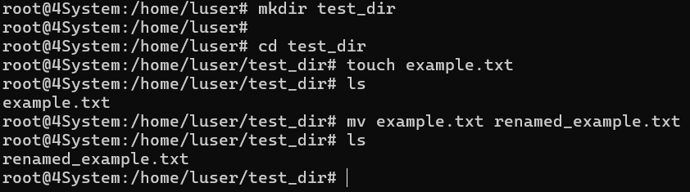

mkdir creates a new directory.

touch creates an empty file.

mv is used to rename or move a file.

2. Viewing File Contents

Use cat to display the contents of /etc/passwd.

Display only the first 5 lines of /etc/passwd using head.

Display only the last 5 lines of /etc/passwd using tail.

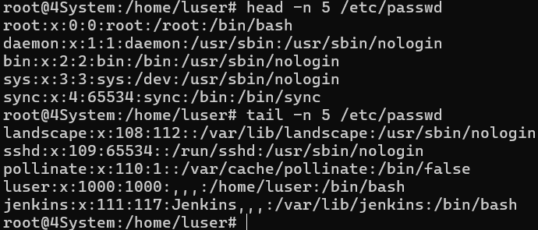

cat displays the file contents.

head shows the first few lines.

tail shows the last few lines.

3.Searching for Patterns

Use grep to find all lines containing the word "root" in /etc/passwd.

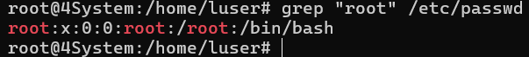

grep searches for lines containing the word “root”.

4. Zipping and Unzipping

Compress the test_dir directory into a file named test_dir.zip using zip.

Unzip test_dir.zip into a new directory named unzipped_dir.

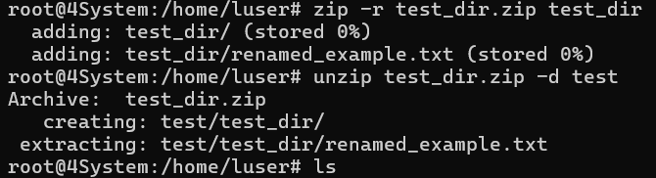

5. Downloading Files

Use wget to download a file from a URL (e.g., <https://example.com/sample.txt>).

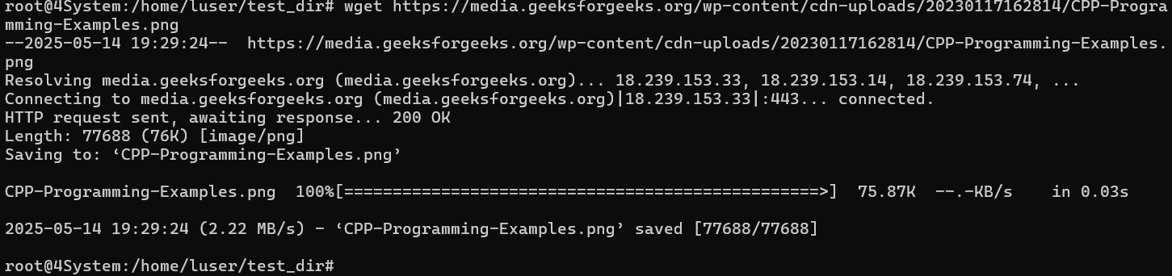

wget downloads files from a given URL.

6. Changing Permissions

Create a file named secure.txt and change its permissions to read-only for everyone using chmod.

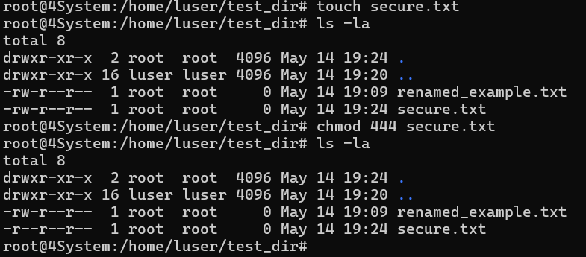

chmod 444 makes the file read-only for everyone.

7. Working with Environment Variables

Use export to set a new environment variable called MY_VAR with the value "Hello, Linux!".

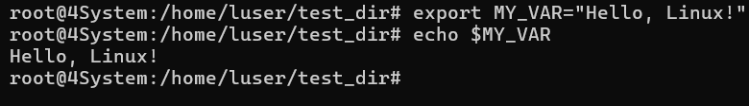

export sets the environment variable.

echo displays it.

**Submission Guidelines -:** Attach Screenshots or command along with explanation and submit in doc(google doc or microsoft doc) format also attach github repo link